1. n=int(input('Enter a number : '))

f=1

for i in range(1,n+1): f=f\*i

print ('Factorial of',n, '=',f)

Co2-1

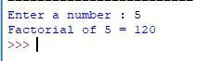

1. n=int(input("enter the limlt"))

a=0

b=1

sum=0

count=1

print("fibonacci series",end="")

while(count<=n):

print(sum,end=" ")

count+=1

a=b

b=sum

sum=a+b

Co2-2



1. list1 = [10, 15, 20, 25, 30]

total = sum(list1)

print("Sum of list : ",total)

Co2-3



1. from math import sqrt as s

for i in range(1000,10000):

if s(i)==int(s(i)) and i%2==0:

print(i,end=" ")

Co2-4

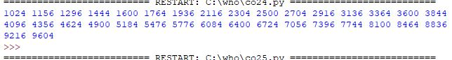

1. rows=int(input("enter a number of rows"))

for i in range(1,rows+1):

for j in range (1,i+1):

print(i\*j,end='')

print()

co2-5

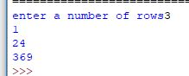

1. str=input("enter a string")

print("inputted string is ",str)

if(str.endswith("ing")):

str=str+'ly'

else:

str=str+'ing'

print("the formatted string is",str)

Co2-7

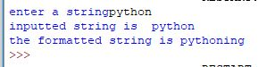

1. a=[]

n=int(input("enter the number of elements in list"))

for x in range(0,n):

element=input("enter element"+str(x+1))

a.append(element)

max1=len(a[0])

temp=a[0]

for i in a:

if(len(i)>max1):

max1=len(i)

temp=i

print("longest word",temp)

print("length of longets word:",max1)

Co2-8

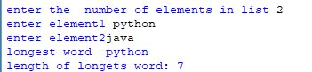

1. n=int(input("enter the limit"))

for i in range(n):

for j in range(i):

print('\*',end="")

print('')

for i in range(n,0,-1):

for j in range(i):

print('\*',end="")

print('')

Co2-9

